Söder Futsal Playbook

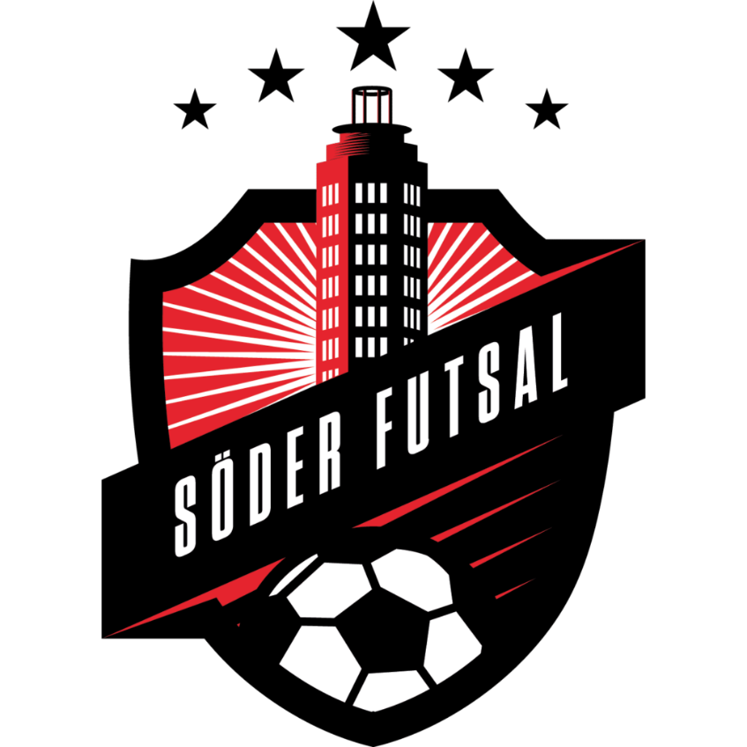

Index
Innehåll
Varför har vi en Playbook? 8
What is futsal? 9
A brief history of futsal 9
International 9
In Sweden 9
Our Club 11
Mission statement 11
The board 11
The committees 11
The statutes 11
Core values 11
Vision 12
Goals 12
Policies 12
Drugs, doping and crime 12
Transfer 12
Behavior 12
Material 12
Salaries 12
Our team 12
Values 12
Goals 12
Team rules 12
The game 13
The laws 13
The pitch 14
Model of Play 15
Tactics 16
Futsal Game Cycle 16
Defence 16
Attack 20
Set plays 24
Kick in 25
25
25
25
Corner 26
26
26
26
Free kick 27
27
27
Preparations 28
for the game 28
for the training 28
Our plan 28
High level plan 28
Mid-level plan 28
Detailed plan 28
Game plan 29
Our team staff 29
Head Coach - John 29
Goalkeeper trainer - Luca 29
Mentor - Bob 29
Sports manager - Lisa 29
Assistant coach - Kim 29
Scout - Betty 29
Spy - Dick 29
Mental coach - Susan 29
Event manager - Greg 30
Liaison Officer - Anders 30
Physio coach - Fred 30
Players board – Raul and Steve 30
Medic / Rehab - Frida 30
General Manager - Adrian 30
Videographer - Dick 30
Video Analyst - Dick 30
Statistician - Dick 30
Media / communications manager - Lisa 31
Kit man - Gunnar 31
Captain (s) – Bob 31
The authors of this playbook 32
Mark Potter 32
Martin Perciavaille 33
Ove Holmberg 34
Thanks 34
Appendix 35
1. Wordlist in different languages 35
2. RASCI 39
3. Pitch template 40
40

Varför har vi en Playbook?
Syftet med denna Playbook är att fungera som ett styrdokument för Söder Futsals löpande verksamhet. Söder Futsals Playbook bygger på en mall framtagen av Potter, Matic och Holmberg. I denna version har mallens ursprungstext behållits för att underlätta och exemplifiera vid fortsatt arbete med denna Playbook. Söder Futsals material skrivs på svenska och skiljer sig på så vis från mallen vars text är på engelska. Söder Futsals Playbook är inte en statisk skrivelse utan ett dokument som lever och utvecklas över tid av föreningens styrelse, sportchef och huvudtränare.

What is futsal?
Daniel Coyle in the book Talent Code defines futsal:
“Futsal compresses soccer’s essential skills into a small box; it places players inside the deep practice zone, making and correcting errors, constantly generating solutions to vivid problems. Players touching the ball 600 percent more often learn far faster, without realizing it, than they would in the vast, bouncy expanse of the outdoor game”
UEFA defines futsal as:
“A collaborative/adversarial team game in which players are required to adapt to a changing, dynamic environment; one in which they have a restricted amount of time and space in which to make decisions and carry out actions that will provide solutions for their team.”
If you go in to details in the UEFA definition it is all about perception, decision making and execution:
- “Adapt to a challenging, dynamic environment…” = Perception – What’s happening?
- “Restricted time…to make decisions” = Decision making – What to do?
- “Carry out actions…” = Execution – How to?

In other words, a game in which a player must perceive in the most effective way, all the arising situations of the game, choosing the best option (decision making) in the shortest time possible and executing it correctly.
But if you ask us futsal coaches, we define futsal as a game for the lovers of tactics and ball technique at the same time. A game for smart and skilled people.

A brief history of futsal

International
Futsal can trace its origins back to the 1930s in Uruguay, South America. The modern version which is now widely recognized and played under the wings of FIFA and global member associations, is generally considered to have been created in the 1980s.

FIFA organises World Cup activity and member associations organize similar competition for participants – i.e. UEFA hold Mens European Championships, Womens Championships and Under 19 tournaments as well as organizing the flagship Club tournament The UEFA Futsal Champions League.

The history of the sport is long and often controversial with many organizations laying claim to governance of the sport, but the global development of the sport, the introduction of coach education programs, owes most to the efforts of FIFA and UEFA. The game most people now play is aligned to the FIFA Futsal Laws of the game.

In Sweden
Futsal in Sweden started 2003 when Stockholm Futsal Club was founded. They started the Swedish championship (SM) and 2005 the first official national team. 2010 the Swedish FA (SvFF) adopted futsal fully into their organization. Sweden have now national teams for youth, men and women and SM for each category. Futsal has become the second biggest sport (after football) if you count the number of players but still there is a lot to do to improve structure and training in the clubs. We hope this playbook will play a role here.

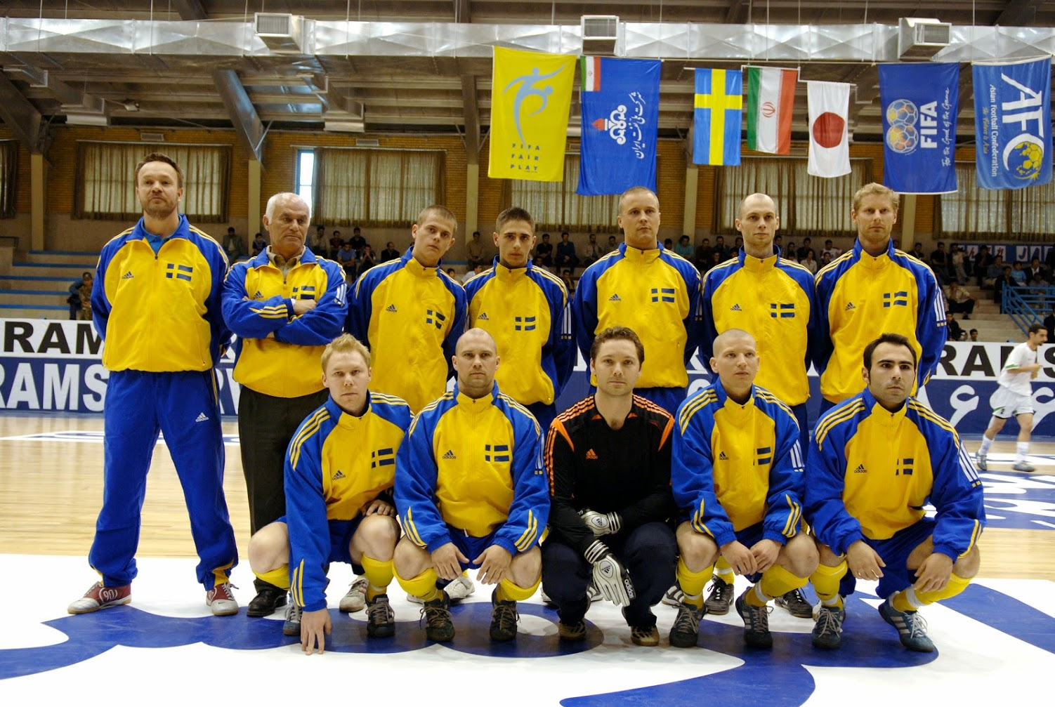
This first official Swedish national team in Teheran 2005.

Our Club
Our Club was founded 2003 in Stockholm by the founder Bob Hope. Since then we have fought for the development of the game in parallel with producing national team players and great teams. Today we have
- 2 men senior teams
- 1 women senior team
- 2 boys youth teams
- 1 girls youth team

Mission statement
Our Club believes that futsal is a sport that will be an important complement to football in the future. We fight for futsal to have the same opportunities to grow as other indoor sports and be available to everyone regardless of gender, age or ethnicity. We do this by showing the sport at its best: with our national team players, with our representation teams and our youth activities - together with football associations, federations, schools and authorities.

The board
The board is people who run and develop Our Club. The board members are selected at the annual meeting based upon interest and skill. Special skills like marketing, IT, finance, and legal are always needed. The board consist today of
- Betty Davies, chairman
- Alan Ball, secretary
- Peter Smith, cashier
- Vacant
- Vacant

The committees
To support the board, we have our committees. Here we continuously are looking for members to help us out.
- Our annual cup. Contact Mr Jim Jones if you want to support our annual cup arrangement.
- Supporters. Contact Ms Lisa Johnson if you are a part of our supporter culture.
- Election. Contact Mr John Smith if you want to apply for a place in the board or a committee.

The statutes
As a member in Our Club you need to understand and adhere to our “club law”, or what we call the statutes. In the statutes we set the standard for who we are and how we do it. The statutes are reviewed at the annual club meeting and every member in the club has one vote to change this. The statutes are a very formal document, so this playbook is a better way to understand how we do it. But remember if there is a conflict between the statues and this document, the statutes are the governing document. The statutes are available from our homepage.

Core values
- We show respect for each other and opponents.
- We have good habits that allow us to trust each other.
- We go all-in and invest in futsal before other sports from October to March.
- We understand that breadth gives the elite, so everyone is welcome to Our Club.
- We work for the integration of people in sports by giving them access to futsal and thereby learning our game, our culture and making new contacts.
- we develop the game of futsal by challenging the status quo.

Vision
- Our Club shall not only become the champions, but also be the #1 futsal club in our country in all aspects. We are the leaders to follow.

Goals
- Our Club shall have at least one national champion each year.
- Our Club shall produce at least one new national team player per year.
- Our Club shall have a sustainable economy with a positive result each year.

Policies
Our policies are what we expect from you to adhere to. Violation against these policies can cause exclusion or suspension from Our Club.

Drugs, doping and crime
- We have zero tolerance for this, and you will be expelled from Our Club. While investigation goes on the board can set you on suspension until done.

Transfer
- We expect other clubs to act just like we do and have a good dialog with the other clubs. Our managers never contact any players we want to transfer without contacting the club they are playing for first. In the case of a non-manager (player, supporter etc.) contacting a player without first contacting our board we will remind him of this policy, not to happen again.

Behavior
- We expect all members of the club to behave according to our statutes and core values.

Material
- All material you have received from the club is for loan if nothing else is told. You need to return this to Our Club if you leave us. Otherwise you will get an invoice on the amount for a new purchase.

Salaries
- No members of the club, including the board, managers and players have a salary for working in the club. All work for the club is on an ideal basis.

Our team

Values
Our team embraces the same values as Our Club with a emphasis on the respect even for spectators and referees.

Goals
Our team shall 2020 win the championships.

Team rules
Except the club rules we have the following team rules
- We always are on time.
- We talk to each other with respect.
If violated, we accept the agreed fine that the players board has agreed upon. The fine sheet is updated by the players board.

The game

The laws

Familiarity with the most current Laws of the Game should be considered a regular part of the training regime. For full version go to this version: https://resources.fifa.com/image/upload/laws-of-the-game-futsal-2020-21.pdf?cloudid=smrcs2kmmsngmf5tf1fi

Futsal has been governed and regulated by FIFA and associated member organisations for over 30 years. A key initiative by the authorities was to standardize the format of the sport globally, to ensure that participants competing in the sport could play against each other with a common set of Laws and regulations which could be clearly followed and accepted.
Many forms of indoor football are played across the globe, but only Futsal has a globally accepted format within the member associations.
The Laws of the game are periodically reviewed, and the game has evolved regularly throughout the last 30 plus years.
Some of the key standards every participant should be aware of:

• Squad sizes are probably larger than people would expect. Although the game is played on the court as 5 v 5, each team can use a squad of 14 players per match. “Flying” or “Rolling” substitutions take place. Every team must have a designated goalkeeper, and there are Laws permitting a “flying” goalkeeper to participate outfield in the game.
• Substitutions can take place at any time and as often as desired. Obviously, teams must only have 5 players on the court at any time, so the player leaving the court must do so before his/her replacement enters. Teams can change any number of players at any time.
• In tournaments or competition suspended players cannot participate so squads of 14 are the maximum but sometimes there can be fewer players available. Players who are dismissed from the game must leave the playing area and cannot remain in the technical area.
• The reason behind the large squad size is down to the intensity and duration of the game. Futsal is played in “real time”. Two 20-minute periods are played and each time the ball is “dead” the clock is stopped. So only when play is ongoing does the clock run down. The small area to play in means players are always under pressure so the intensity of the game increases when the ball is in play – hence the requirement for repeated personnel changes. Some games from first kick off to final whistle can last 90 minutes or more.
• Each team is permitted one time out per half (so potentially four time-outs per game) which facilitates tactical initiatives from the teams.
• In Cup competitions, games can go into extra time, then penalties. Extra time comprises two 5-minute periods (again, stop clock but with no time out allowance). If games are still drawn, then penalties are taken – and there are regulations on the format for the penalty shoot-out.
• Each match in national and international futsal has four officials. Two Referees (with one allocated as Head referee) manage the on-court action, a third referee manages the off court participants and staff, and liaises with the fourth official; the timekeeper (who manages the stop clock and records on court action such as fouls, goals, cards etc).
• The timekeeper ensures that “accumulated” fouls are recorded and notified to the match officials. Once a team commits five fouls, they are advised by the match officials and any further accumulated fouls result in a free shot from the 10m penalty mark (or where the foul occurred if this is closer and more advantageous to the attacking team). At the end of the first half, the accumulated fouls are reset to zero. If a game goes to extra time, the foul count is not reset and continues until the end of the match.
• There are several infringements which result in an accumulated foul. Many of those could result in a caution or dismissal for a player. If a player is sent off, the penalized team play one man short for two minutes, unless they concede during that time in which case they return to full strength immediately. The player that was sent off, however, cannot be used again.
• In Futsal the penalty area is a full part of the playing area. Players can enter and goalkeepers can leave the penalty area. In the case of the goalkeeper restarting play, the ball must leave the penalty area. Once the goalkeeper has passed the ball to a teammate, he/she cannot control a pass back from a team mate until the ball has been touched by an opponent.
• The goalkeeper cannot control the ball with his/her hands after a pass from a teammate and must release the ball within no more than 4 seconds of receiving control of the ball. When restarting play, the goalkeeper must throw the ball out.
• When the ball goes out of play along the sideline then a kick in is taken. The team which last touched the ball defends the kick in. If the ball goes out along the goal line, the it is either a goal clearance or a corner, depending on which team last touched the ball.
• A goal can be scored from a corner, but cannot be scored from a kick in.
• For kick-ins, free-kicks, goal clearances and corner kicks, the player in possession of the ball has four seconds to restart play which the referee demonstrate visually. If play isn't restarted within four seconds an indirect free kick will be awarded to the opposing team. The goalkeeper is not allowed to control the ball for more than four seconds in his own half.

The pitch
The boundary lines are in play.
In the event that the court width is between 15 and 16m, the penalty area is only 4m from the edge of the goal posts. The penalty mark remains at 6m. The goals are 3m wide by 2m high by 1m deep (at floor).
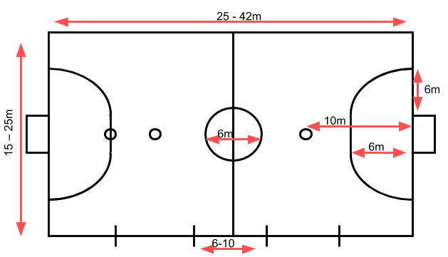

Model of Play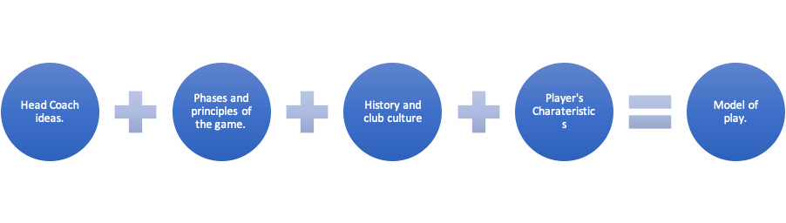
The creation of the model of play is very important for the coach, it takes long hours to create it but it will help players and coaching staff to understand how the team will play offensively and defensively, by eliminating players' doubts, becoming as such more efficient to obtain optimal performance.

There are 3 main concepts to take into consideration:

- The principles: General idea of how we want to attack/defend.
- The how to: Technical & Tactical Tools to be used to fulfil our principles.
- Guidelines: Actions to be taken during a specific time of the game or in special situations. What to do if there is an exception.

Model of play example from a defensive perspective:

Principles | How to | Guidelines
- Respect defending lines.  - Always behind the line of the ball.  - Move when the ball moves.  - Force mistakes do not steal. | - Press  - Cover  - Jumps  - Line of pass defence  - Defensive triangles  - Defensive rotations | - 1v1 (inside/outside)  - Defensive helps  - Blocks  - Opponent playing between lines

Tactics
Before getting into the basics of attack and defence we need to understand the tactical structure of futsal. Below a diagram that will help you to understand the game.
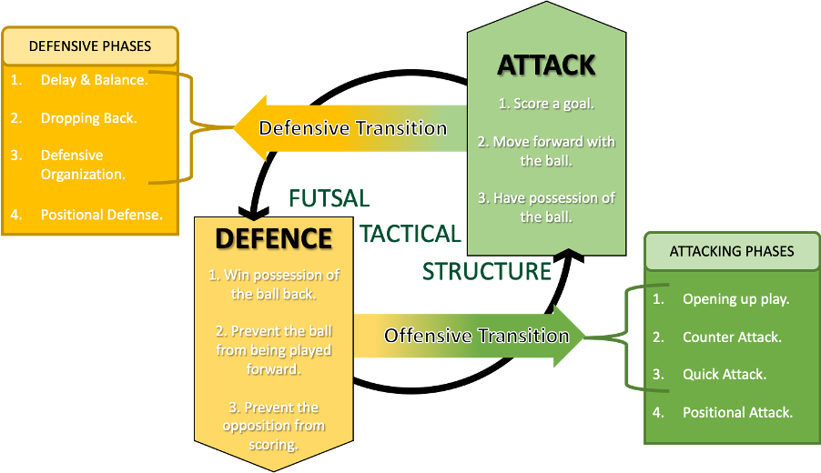

Futsal Game Cycle
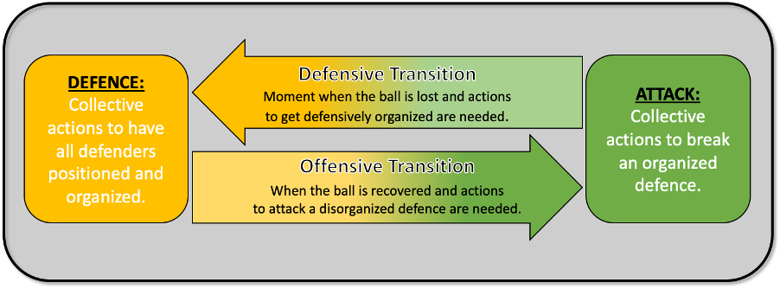

Defence
The Defensive Tactics are all those individual and collective actions that players perform when their team is not in possession of the ball, trying to counteract or condition their opponent to achieve the defences aims (Regain Possession, Prevent Progression, Prevent Finishing).

Those individual and collective actions are based on defending principles:
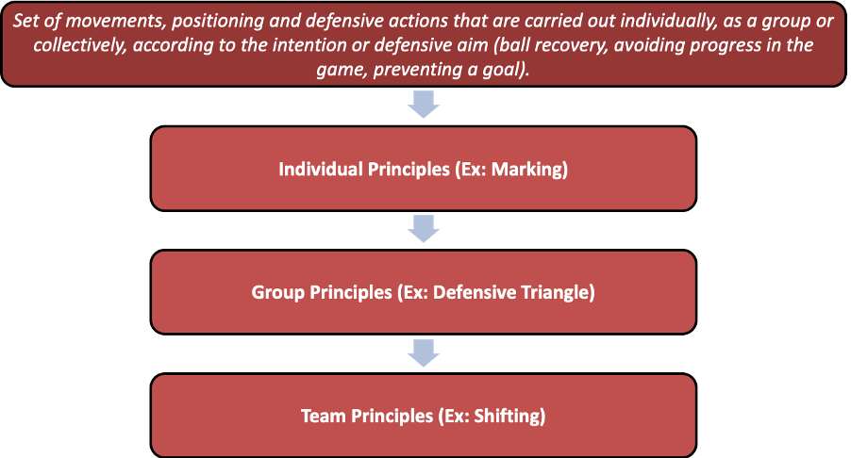

The defending phases of play can be divided in 3; defensive transition, positional defence and set pieces. All of them have subphases, see below diagram.
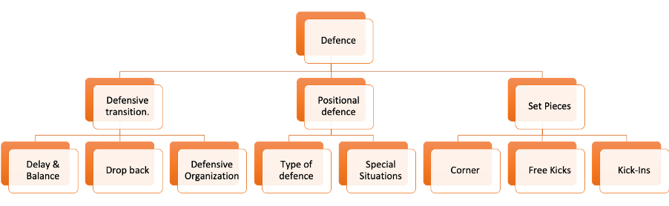

The aim of the defensive transition is to prevent the attacking aims from the opponent by stopping their break into attack, dropping back as quickly as possible in order to cover and defend the space in an organized way and thereby initiate positional defence.

- Balance: Position of the attacking players at the moment of losing ball.
- Delay: Prevent the advancement of the opponent's play by either pressing the player in possession of the ball and/or defending line of passes.
- Dropping back: Get as fast as possible behind the imaginary line of the ball and/or organize defensively.
- Defensive organization: 4 players behind the imaginary line of the ball and organized.

When the defensive transition is over and we start our positional defence, we need to think about the constructions of that defence. This construction will depend on the playing space and the height of our defensive lines: High Pressing Defences, Open Defences (3/4), Closed Defences, etc. We can divide the pitch in 4 defending zones:

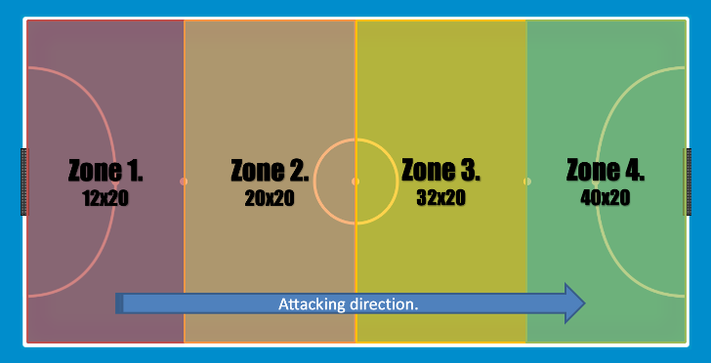

There are 4 types of defences
- Individual
- Individual w/Change
- Zona
- Mixed.

Once you have decided the type of defence you will like to use in your model of play you need to decide the type behavior.

- Holding defence: Blocking lines of passes but no real pressure on the ball, and patiently waiting for a mistake.
- Pressing defence: Blocking lines of passes and real pressure on the ball to force the mistake from the opponent.

It is important to understand that “Type of Defence” and “Defensive Systems” are 2 different things.

- Type of Defence: is the cooperative actions between players (tactical procedures), based on the foundations of individual tactics (Group of actions made by a player based on their knowledge and on core individual tactical concepts), but applied with a common goal in a group setting.
- Defensive Systems: The alignment, distribution or positioning of players and their coordinated action has been established beforehand. Basic Organisation.

There 3 common defensive system:

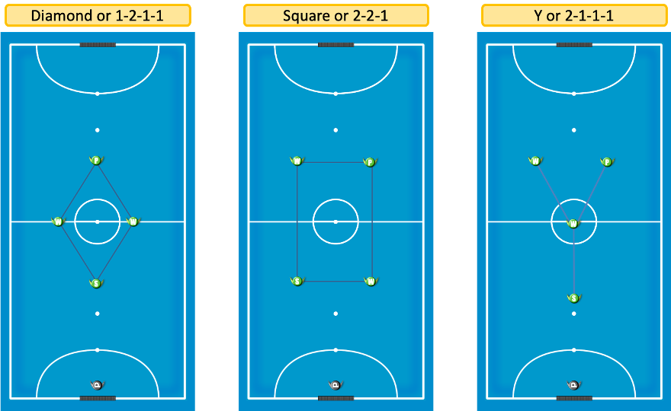

Based on the opponent attacking play, the defending team will need to start their positional defence with one of those 3 defensive systems.

Example: If the opponent's starting position when their GK has the ball is 2 at the back and 2 in front, your team will need to start with a square formation.

Special situations are situations in which the team is positionally defending an outnumbered situation: Powerplay (Flying Keeper), Red Card (2mins without a player). For those situations, the team needs to have a defensive system in place and the players need to be fully aware about the type of defence applicable during those situations, the defensive system to use and the specific roles.

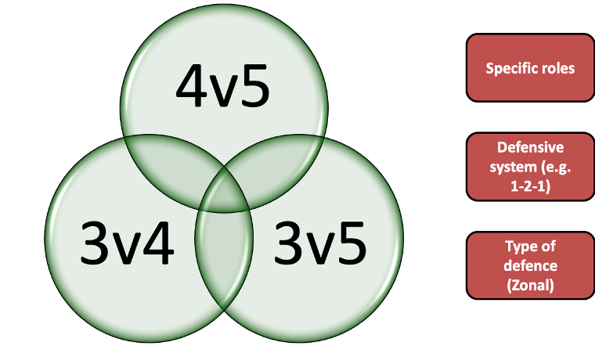

Attack
Offensive tactics are all the individual and collective actions that players in a team make when they are in possession of the ball, attempting to break the opposition defence to achieve the objectives of the attack. All those actions are performed as part of the attacking phases.

Those individual and collective actions are based on attacking principles: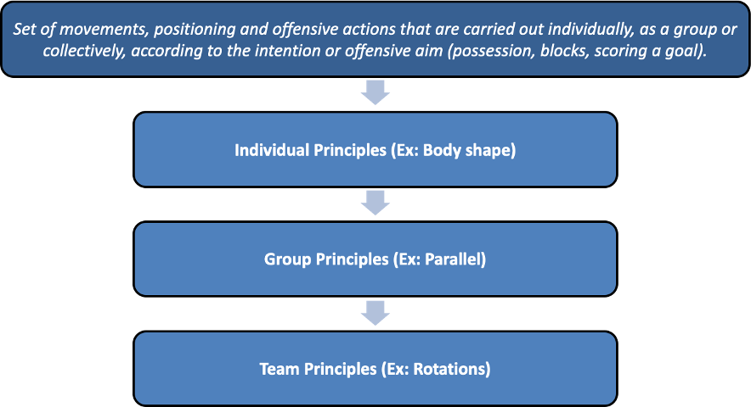
The attacking phases of play can be divided in 3; offensive transition, positional attack and set pieces. Each one of them have their own subphases, see below diagram
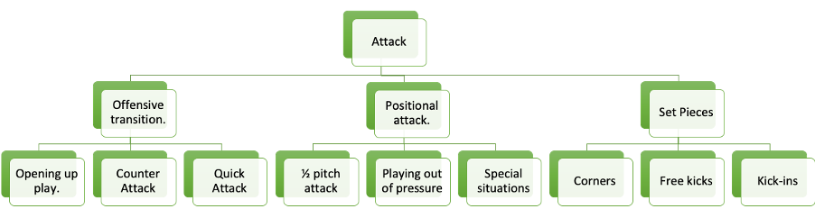
The aim of the attacking transition is to prevent the defensive aims from the opponent by breaking into attack and counterattack as quick as possible preventing the opponent to get defensively organized in order to score a goal or initiate positional defence.
- Opening up play: This represents the first pass/dribble of the offensive transition after the recovery of the ball, avoiding in the first instance balance and defensive withdrawal.
- Counterattack: This the offensive action of reaching the opposing goal, before the four defenders are in a position to defend. All four are not behind the ball's line.
- Quick attack: Intention to attack quickly when the four players of the defending team are behind the ball, but are not organized defensively, looking for a positional advantage anticipating their defensive organization.
When the offensive transition is over and the positional attack starts, players need to understand that this phase represents the way the team organize and coordinate the attacking actions of all players to effectively occupy the areas of the pitch, ensuring a good possession of the ball once the 4 defenders from the opponent team are defensively organized and using their positional defence.
There are 3 attacking zones:
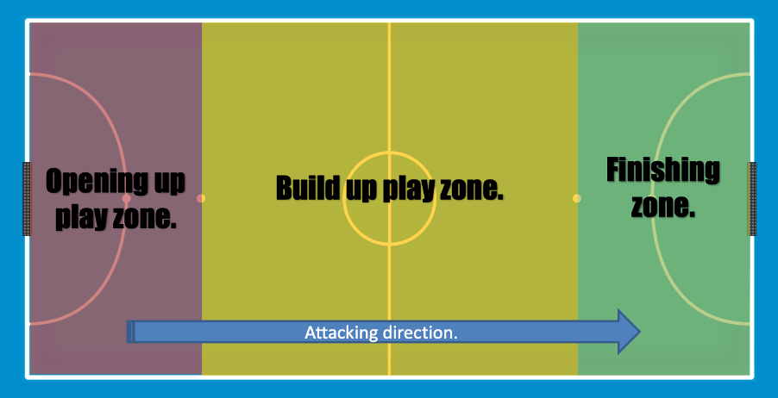

Players need not only to understand those zones but also know what to do in each one of them. For example, if your attacking system is 1-3-1, the more advanced player (pivot) needs to understand his/her area of play is in the finishing zone, if that player moves to the build-up play, the attacking system changes to 1-4-0.
There are also, 3 attacking channels:
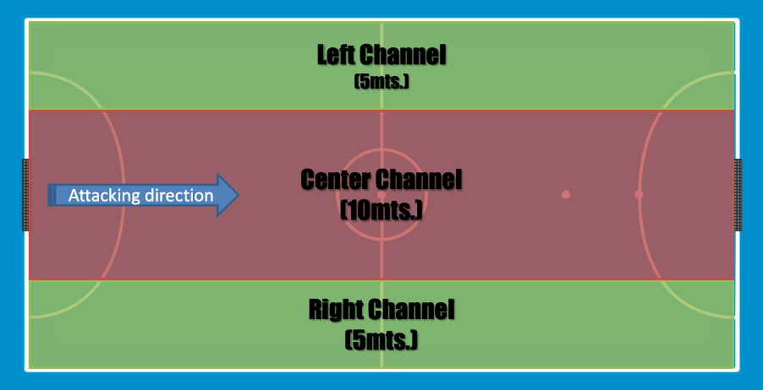
This is very important as when the attacking team is breaking into attack to start the counterattack phase, those 3 channels need to be occupied as soon as possible, having the ball always in the center channel.
When talking about offensive tactics it is important to understand the number of players participation in the action.

INDIVIDUAL TACTICS | GROUP TACTICS | TEAM TACTICS
- Attacker with the ball.  - Attacker without the ball.  - Defender of the attacker with the ball.  - Defender of the attacker without the ball.  - Goalkeeper. | - 2v2  - 3v3  - 2vGk  - 2v1+Gk  - 3v1+Gk  - 3v2+Gk | - 4+Gk vs 4+Gk (Relationship of all players)  - Special situations 5v4 and 4v3

The positional attack represents the way to organize and coordinate the actions of all players in attack, in order to effectively occupy the areas of the field and ensure the possession of the ball and finishing it by scoring a goal.
Within the positional attack (team tactics) there are several offensive/playing systems:
- 1-3-1
- 1-1-3 (Russia, with Robinho)
- 1-2-2
- 1-4-0
- Special situation 5v4 (Powerplay)
- Special situation 4v3 (red card)
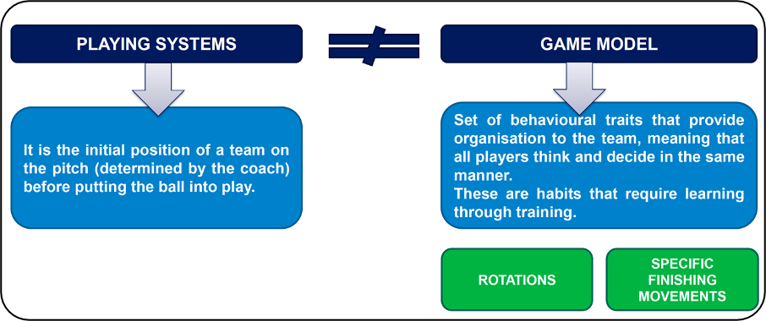

Special situations in attack are situations in which the team attacks against an outnumbered positional defence using a powerplay (Flying Keeper) system or because a player from the opponent team received a red card (2mins without a player). For those situations, the team needs to have an attacking system in place and the players need to be fully aware about the type of attack applicable during those situations, the attacking system to use and the specific roles for each one of them.

Set plays
Set plays in Futsal offer teams the opportunity to implement learned and practiced routines to gain an advantage over the defending opponent.

The defending team will invariably adopt a standard team process for covering shape or defensive positions when the attacking opponent has a set play but should be prepared to react quickly to movements or routines as they occur. This becomes very much about individual player responsibility and discipline and communication with teammates.

The coach cannot prepare the defending team for every eventuality or pattern from the attacking team, so players must be able to assess danger and try to cover. Ultimately, though, many goals are scored from set plays.

The most common set play in Futsal is the kick in. Too often it is simply used to restart play, but it should be considered an ideal opportunity to initiate a set play which each member of the on-court team understands and can implement.

Corners can occur regularly and are again a source of potential advantage, although the defensive team does have the opportunity to crowd the area in front of goal and an over-ambitious attack can find itself exposed to a counterattack – after all one of the attacking players is actually the wrong side of the ball if the defence steals the ball.

Free kicks offer the best chance of scoring a goal. The attacking team can have several options, should always have cover, and can often offer options either left or right sided.

These tend to occur less often for obvious reasons, the 5-foul rule means the defensive team rarely gives up more than that number of fouls so whereas there can be many kick ins, several corners, there are usually less free kicks. As a player in Our team you are expected to understand our three basic set plays om the following pages.

Legend for the illustrations:

 Red player with a triangle is Our team. This player is referred as R2.
 Blue player with a circle is Our opponents. This player is referred as B4.
 Green player with a triangle is our goalie and green player with a circle is the opponent goalie. This player always has #1.

Movement of the player
Movement of the ball

Kick in
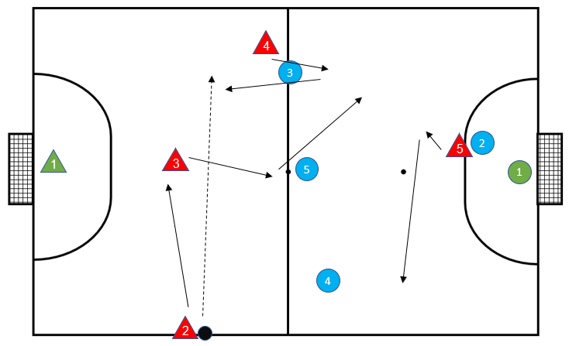 | The kick in starts with the following positions.  - R4 feints to run forward and puts B3 on “back foot”. R4 then drop back to receive pass from R2.  - As R2 passes across court, R3 “dummies” the ball and indicates to run to the left of B5. B5 must cover the run so steps left and R3 feints to go into the space behind B3. R3 is now behind the defensive lines.  - R5 feints away from the ball then sprints back towards the side of the court where the kick is taken. B2 must cover.
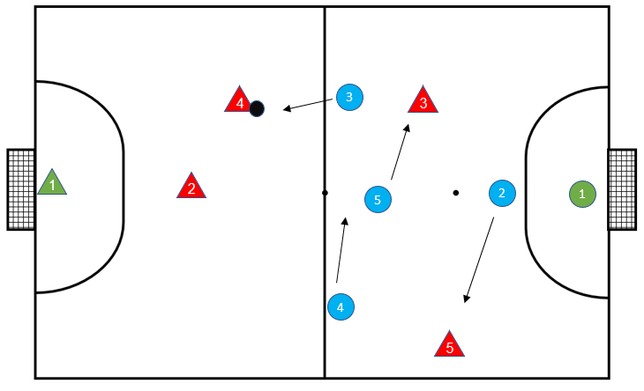 | R4 now has options – first touch with sole, roll inside and play in to R3 who may have clear run to goal or play across court to R5.  - If B5 covers R3 passing line, then R5 becomes the option.  - If B4 covers that passing line, then R2 is an option, or R5 continues to run into wide area (near centre circle) to offer further pass. If this option is taken, then R4 can make a diagonal run between B4 and B5 for the parallel pass from R5.  So many options designed to move defending team out of position, all stemming from one starting set play.
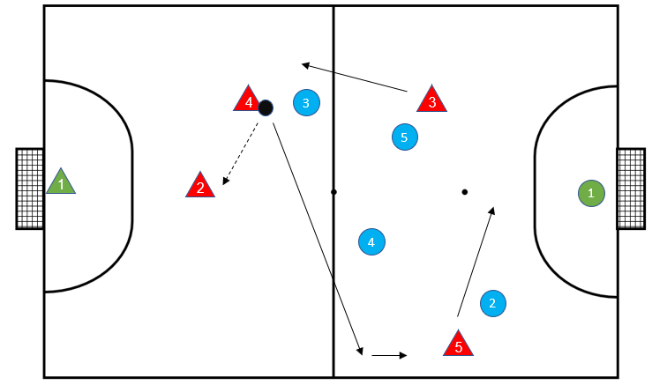 | If B team cover all the forward passing or moving options, then the “safe” pass is to R2. But R4 must continue to manipulate space behind the B team. By running across the face of B3 and B4 R4 creates an imbalance.  - R2 then has option to play in to R3 while R5 breaks the defensive line back into the pivot or back post position.  But key is to have these rotations in play established from the first pass at the kick in.

Corner
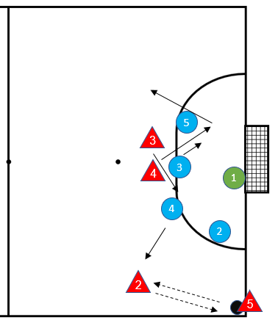 | Our opponents have set up as traditional zone marking to defend corner. Our team must try to create space to open a shooting opportunity. R3 and R4 are vital to this, both creating space and providing cover. The timing of the movement is key.  - The first pass R5 to R2 sets the play. B4 must move forward to close the space for R2 otherwise R2 can manipulate a shot.  - As this pass is made, R4 makes deep run to pull B3 back towards goal This opens a line for R3 to move towards the ball. R4s movement also blocks B5 following R3s run.
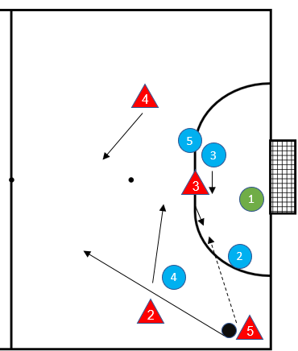 | - R5 plays ball inside to R3. B3 realizes he must cover this run or R3 is open. B5 tracks R4 run to cover pass to R4.  - R2 cuts inside of B4. R5 pass must be on “safe side” of R3 (ie furthest away from B3.
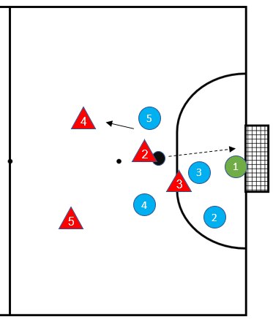 | - R3 controls the pace of the ball and rolls pass into run of R2 who shoots for goal. There are many options. R2 can miss the ball again and cross to block B5 for R4 to come around for the shot. If Blue team cover or intercept, R4 and R5 provide cover.

Free kick
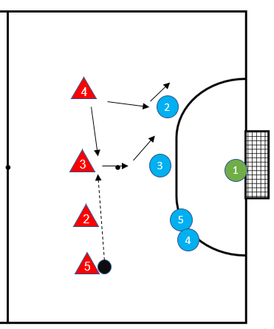 | R5 is in wide area so a shot on goal is unlikely. However, Red Team must give Blue team different considerations, or this will be a wasted opportunity. From here, R5 can play to all 3 team mates individually in their position (so if there is a strong pivot he could be used as a pass to hold the ball for subsequent movement). The GK could also come forward to provide an extra challenge although this is risky, and probably only used if a team is trailing. In this case however, R5 will use R2 and R3 as decoys/blocks for R4 to shoot.
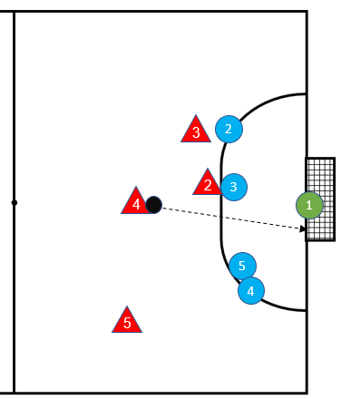 | R4 must time the run to meet the ball when R3 and R2 are blocking the covering defenders. This must be done quickly to limit the time for the goalkeeper to get across.  If shot is not on then R4 must retain the ball and avoid counterattack.  By playing to R5 then R4 and R2 must provide a barrier to allow R5 to regroup. R5 must also have options. Option 1 is obviously back to the goalkeeper, but to maintain momentum on the attack R3 can provide option.

Preparations
To make sure we are on the right place at the right time with the expected material we prepare.

for the game
- For home games we gather -90 minutes prior kickoff at Joes restaurant where you are served coffee. You bring shoes, shin pads and a towel for the shower. All other material is provided by the team. For away games we meet at Joes as announced from time to time.
- -60 We shall be in our dressing room.
- -40 Coach presents the game of the day and tactics
- -30 We do warm up
- -10 We are back in the dressing room for final preparations
- -5 We walk out on the pitch

for the training
- Latest -15 minutes prior session you should be in the dressing room. You bring your shirt, socks and trousers provided by the club plus shin pads and a towel for the shower.
- Do not enter the training pitch until time.
- +15 minutes after the session starts, you should have warmed up with or without someone leading this.
- +20 minutes, Coach presents the session of the day.

Our plan
Planning aims to visualize the way to the goal, i.e. how and when we should do different activities. Change is constant and we embrace Kaizen (the Japanese word for continuous improvement). This means we do retrospectives on our way of working and for each time we become a little bit better and by that change the plan to match the new learnings.
It is the manager's job together with the sports manager and head coach who submit the high-level plan to the board for approval. Then the other plans follow, aligned with this plan. You make several plans at different levels, but first you must set the goal and the vision. We assume here that the vision is to win the European Championship and the goal of this season is to go up in the highest division.

Then the different plans may look as follows.

High level plan
In this plan, we talk about a perspective of one to three years including training camps, series games, cups and milestones, such as possible promotion. This plan is only changed by the Board annually. It also shows what the whole party will cost with travel and possible salaries.

Mid-level plan
This plan is on a seasonal basis, for example, between September-March and shows all the main activities such as matches, transfer windows, possible relationship with the farmer's team and others during the season. This plan is changed monthly by the sports head and head coach in consultation.

Detailed plan
The detailed plan is on a weekly or maximum three-week basis. Here we talk about exactly what parts we practice on what things and when we do any tests to verify status. This plan is changed weekly by the head coach.

Game plan
Also consider having a clear game plan. That could be playing defensive and counterattack but make sure you always have a plan B and C the players can execute if plan A fails.

Our team staff
To become a professional club we need a great organisation. These are the roles we have and the people are behind the scenes or the match program. Several of the roles can be shouldered by one and the same person but at least five, max ten people we would consider a good staff lineup. Who does what is detailed in our RASCI, found in the appendix.

Head Coach - John
Responsible for the sporting goal being achieved and training the team in the way towards this and ensuring that the team is measurably better from match to match. Experience from being a player on a high level or/and a relevant education is needed.

Goalkeeper trainer - Luca
Special goalkeeper training in the club where 5-6 goalkeepers participate without players will be held by the Goalkeeper trainer. During ordinary training the Goalkeeper trainer has 30 minutes at disposal for specific goalkeeper training. During games the goalkeeper coach focuses on coaching the goalkeepers and giving feedback after each attack.

Mentor - Bob
If the some in the staff is non-experienced in some roles the mentor as an experienced person can support from behind the scenes. Ex: If the head coach has no formal education then the mentor can cover for this.

Sports manager - Lisa
Keeping the vision alive by the right player coming and the right player going. The sports manager is appointed by the board and together with the head coach ensures that the right players join Our Club

Assistant coach - Kim
It is not possible to keep up with the changes and be a daddy to players who are moaning about choking or some playing time. The assistant coach does this instead. He walks around talking to the players and suggests changes to the head coach. He benches too hot players and makes sure there are no red cards. He has a close dialogue with the captains and the head coach.

Scout - Betty
The scout is often the same as the sports manager and has the task of attracting the players for the next season. Often by watching matches played in the same region in lower series.

Spy - Dick
The spy sees all the matches in our own series, often played at the same time as our matches. It is important to spy on our opponents in the next match to find out their tactics and which players to keep an eye on. Information is power, it is said. Here we get lots of information we can use in the short term.

Mental coach - Susan
If you, like me, have a great deal of privacy then there may be reasons to have someone to talk to if you feel it is tough. A person who can be a player if there are these qualities.

Event manager - Greg
The event manager is a person who is responsible for all our home games including marketing, ticketing, security, the arena, speaker, filming and cleaning. This is done by managing a crew for all this work.

Liaison Officer - Anders
The LO is responsible for the relationships between Our Club and the club we are playing against. At home the LO makes sure the other team and their supporters have a great time visiting us. It can include making local arrangements such as finding a hotel and tickets for the supporters but also security aspects around the game.

Physio coach - Fred
The physio coach is a physiologically trained person who is responsible for making the players well prepared for the start of the season physically. When the season ends, he, together with the player, sets personal goals for test values ​​in October and makes a summer program for this. In August, the first test will be done to see if the summer training is done. Then 1-2 physical / fitness exercises per week, depending on needs until the start of the series. During the season he conducts physio training when needed.

Players board – Raul and Steve
The Players board consists of 2-3 players who voluntarily want to be the players' voice in the club. Can receive complaints that players dare not raise with management and need to be submitted anonymously. Is then done by the player council. The Players board also sets the internal rules with possible late arrival fines, etc. The player board is appointed by request to everyone. If more than three signs up, then voting is done among the players. The players board is responsible for governing the team values and team rules.

Medic / Rehab - Frida
A person who is trained in health care primarily to tape and massage half-injured players before the match, but also to deal with major problems during the match. Skilled with cardiopulmonary rescue.

General Manager - Adrian
This person will ensure that all administrations work around the team with team set-ups and contacts with the competition management. Also, make sure the team is called and located in the right place, at the right time and with the right equipment. A bargain may seem like it, but he is in charge of the key to the dressing room and is last from there and first in before, after and at half time on the match. Have overall responsibility for all tasks in the team and ensure delegation, e.g. through a RASCI.

Videographer - Dick
A person who has a good camera on a tripod. Preferably filming a match from the short side where our goalkeeper stands to avoid turning the camera but also get an angle that the players recognize. Ensures that the film is provided to the players no later than 12 hours after the match.

Video Analyst - Dick
Filming a difficult thing but analyzing the film takes a long time and then getting the material into modern programs for analysis type Sideline requires a specialist. If the match is played in the evening, an analysis will be completed in the middle of the night at the earliest. The analysis is therefore usually done by the head coach getting the raw film and going through this with the team.

Statistician - Dick
A person sitting on the stand and for statistics of the match. Ball possession and shots on goal are important info that he can provide during the match to the coach to verify the coach's thoughts on adjustments. For example, in the timeout or in half. Other statistics such as shots from which positions, what types of goals etc. are saved after the match. Also, data can be aggregated from tools such as Instat.

Media / communications manager - Lisa
He ensures that our matches are filmed and photographed and ends up online, and that sponsors, and audiences are drawn to our matches and that the head coach receives feedback. Social media is the main tool for this.

Kit man - Gunnar
A Kit man is first and foremost a person who has order and clarity in the dressing room but also someone who can contribute with a fun mood.

Captain (s) – Bob
The Captain is the head coach's extended arm and is selected by the players. Minimum requirement is to have played one season for Our Club and strong leadership skills.

The authors of this playbook

Mark Potter
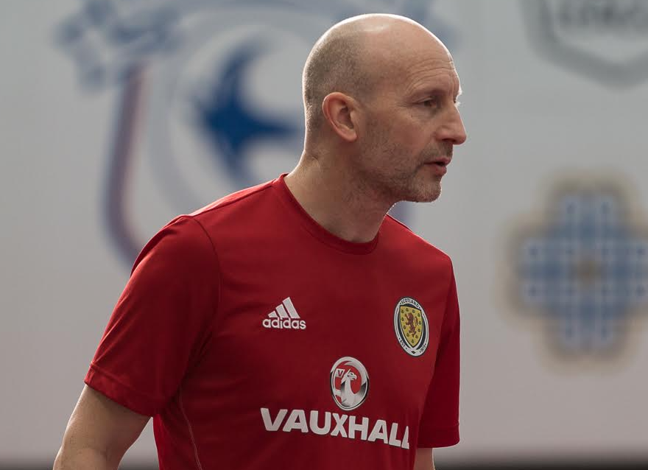

Mark has been involved with Futsal for over 20 years and has pioneered the sport of Futsal in Scotland since 1997. In 2018 Mark successfully completed the UEFA futsal B license in Finland becoming the first Scottish license holder.
Mark has been a consultant coach with British University and British Maccabi teams, and has a history of producing successful teams. A UEFA B Football coach, he has an extensive understanding of the technical and tactical requirements of the sport and was a key stakeholder in the establishment of the Scottish Futsal League, involved in the development of the Scotland National Team and a contributor to the SFA Futsal Coach Education program.

Martin Perciavaille
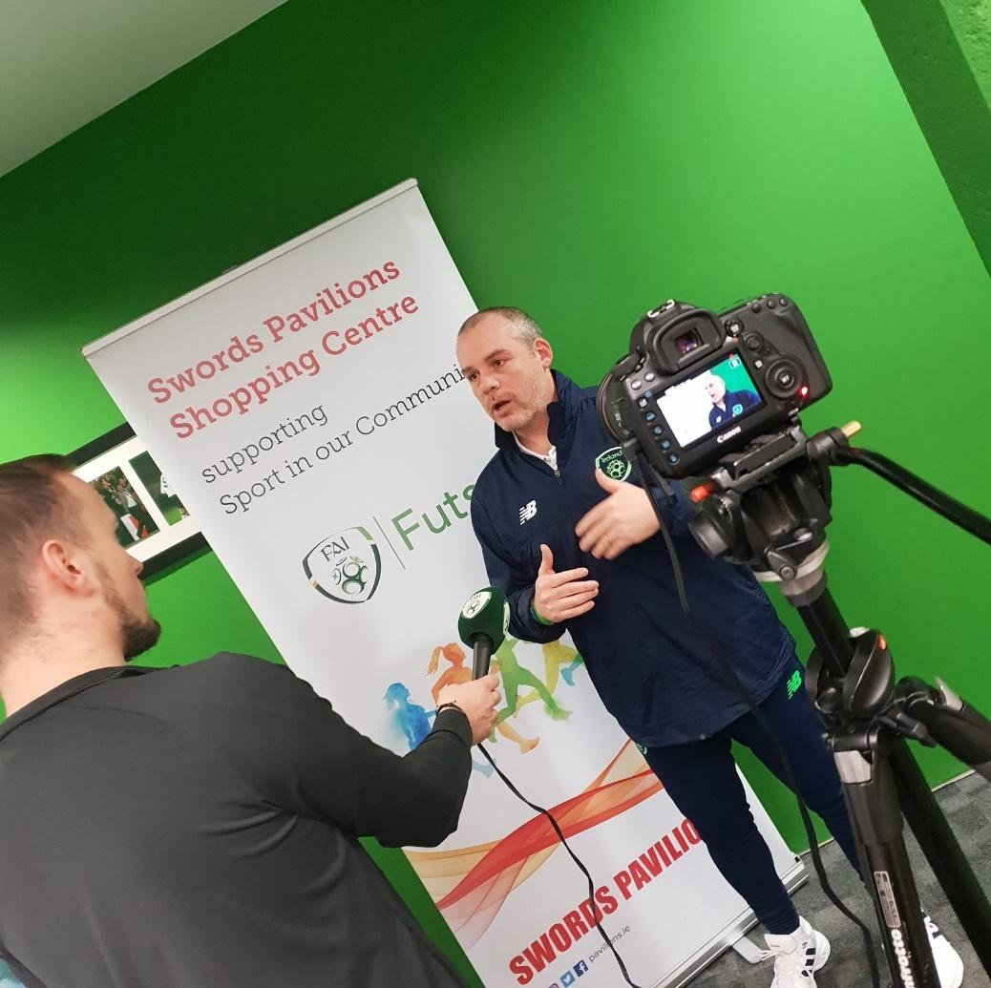

Current holder of the Futsal UEFA B License who established an exceptional reputation at underage and senior level players over the course of a 14 years of coaching career in the Republic of Ireland. He played and continues to play a key role in the development of futsal in the country and since 2015 he has been collaborating with the Football Association of Ireland (FAI) not only creating content but also delivering their futsal coaching licenses.
Most recently hired as a futsal consultant for the Futsal Association of Trinidad and Tobago to deliver futsal courses in the island and develop content for their futsal academies (U8 to U15).
He is a high skilled futsal coach with the ability to design and deliver long term programs in line with club’s development strategy and playing philosophy. He is always looking to improve and challenge himself and those around him, and worked with Ireland’s best futsal players, being an invaluable resource for any club or National team seeking to produce high caliber talents and/or build a competitive team.

Ove Holmberg
Ove started futsal in Sweden 2003 and has since then been a developer of the sport. With a profession as organization developer he contributes to this book with inspiration on how to run a club/team more professional - like a company. At work he does the other way around - coaching software people to work as teams.
Ove has a UEFA B-license in futsal and 30 years of coaching football and futsal on different levels from youth to the Swedish national team for deaf.

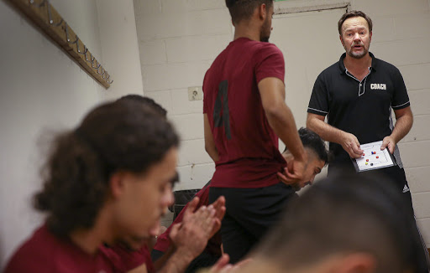

Thanks
We would like to thank the following people for the feedback on this playbook
- Mico Martic for corrections and feedback
- Joakm Folmer Hansen, Märsta IK for great feedback on the format.
- Joakim Eriksson, Hammarby Futsal for inspiration.

Appendix

Wordlist in different languages

Swedish word | English word | Croatian word | Spanish word
Anfallssystem | Attacking System | Sustav napada | Sistema de ataque
Bakdörr | Backdoor | Straznja vrata (iza ledja) | Puerta trasera
Ytan mellan försvarslinjerna | Between the lines | Izmedju linija | Entre líneas
Screening | Block | Blok | Bloqueo
Hög press | Closed defence | Visoki presing | Defensa cerrada
Kontring | Counter-Attack | Kontra napad | Contraataque
Gardin | Curtain | Zavjesa | Cortina
Defensiv höjd | Defensive height | Obrambena visina | Altura defensiva
Försvarslinje | Defensive line | Obrambena linija | Linea defensiva
Fördröjning | Delaying | Odgoda | Retrasar
Bollförsvarare | Direct Opponent | Izravni protivnik | Oponente directo
Mixed försvar | Defence with Exchanges | Mjesovita obrana | Defensa mixta
Komma ur press | Exit the press | Izlazak iz presinga | Salida de presión
Snabb attack | Fast Attack | Protunapad | Ataque rápido
Fint | Feint | Lazno kretanje | Fintar
Flygande målvakt | Flying Goalkeeper | Aktivni golman | Portero-jugador
Isolering | Isolation | Flaster | Aislamiento
Uppspel | Backplay | Igra otraga (igra "okolo") | Reconstrución de juego
Man-man försvar | Man to Man Defence | Obrana - covjek na covjeka | Defensa individual
Power-/box play | Numerical superiority/inferiority | Igrac vise/igrac manje | Superioridad/inferioridad númerica
Passningslinje | Passing Line | Linija dodavanja | Línea de pase
Parallell | Parallel | Paralela | Paralelo
Target/Pivot | Pivot | Pivot | Pivot
Press av bollhållare | Pressure | Presing na loptu | Presión
Press som taktik | Pressing | Takticki presing | Presionar
Organiserat anfall | Positional Attack | Organizirani napad | Ataque posicionado
Hemjobb | Recovery | Povratak u obranu | Repliegue
Rörelser | Rotations | Rotacija | Rotaciones
Fasta situationer | Set Plays/Set Pieces | Prekidi | Estrategia
Starka sidan | Strong Side | Jaca strana | Lado fuerte
Spelövergång | Transition | Tranzicija | Transición
Vinge | Winger | Krilo | Ala
Zonförsvar | Zonal Defence | Zonska obrana | Defensa en zona
Målvakt | Keeper | Golman/vratar | Portero
Försvarare | Defender | Obrambeni igrac | Cierre
Passa | Pass | Dodavanje | Pase
Sula | Sole | Djon | Planta del pie
Jobba hem/Försvara | Defend! | Brani! | Defiende!
Markera | Man-man | Markiranje | Defensa individual
Byte | Change | Izmjena | Cambio
Halvlek | Half-time | Poluvrijeme | Descanso
Lugna ner | Calm | Mirno | Calma
Tålamod | Patience | Strpljenje | Paciencia
Vila hemma | Rest home | Odmor u obrani | Descansar en casa
Kämpa | Fight | Borba | Pelear
Bra | Good | Dobro | Bueno / Bien
Bättre | Better | Bolje | Mejor
Pivot | Pivot | Pivot | Pivot
Vinge | Wing | Krilo | Ala
Inspark | Kick-in | Golmanova lopta | Colgar balón
Diagonal | Diagonal | Dijagonala | Diagonal
Bortre stolpen | Far post | Druga stativa | Palo largo / Segundo palo
Etablering av spel | Establish play | Uspostavljanje igre | Establecimiento de juego

RASCI
This matrix is used for clarifying on expectations for each role in the team.

- R = Responsible. The person who do the job.
- A = Accountable. The person who gets the credit/blame after it is done, delegates the job to R based upon trust.
- S = Supportive. The person who can pair up with the R to get the job done.
- C = Consulted. The person having deep knowledge can be asked for advice.
- I = Informed. The person that has no impact but is interested in the outcome and can give feedback on this.

Role > | The board | Head coach | Ass coach | Manager | Player | Kit man
Name > |  | Bob | Billy | Bengt |  | Benny
Lead the team in games |  | R | C | A | I | S
Lead the team in trainings |  | A | R | I | I | S
Recruit players | A | C | C | R | S | S
Right jersey at games |  |  | C | A | I | R

Pitch template
